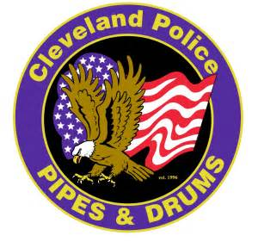

On September 25, 2021, the Pipes and Drums of the Cleveland Police, will be hosting our 25th Anniversary Celebration at the Crawford Auto and Aviation Museum. As part of the evening’s festivities, we will be producing a program to highlight the band’s history, our members we have lost, as well as recognizing our sponsors and friends who have supported us over the past two and a half decades. We are asking you to please consider purchasing a program ad to help us in this effort. There will be four different levels of support for this project.
Full Page Ad-$200.00
Half page Ad-$100.00
Quarter Page Ad-$50.00
Patron Level-$20.00 (Example-Best wishes from Mr. and Mrs. Smith or In memory of…)
(Complete this section for Patron Ads ONLY-One block equals one letter, number, character or space)

For those wishing to purchase an ad we would please ask the following:
- Email to: rcd296@aol.com
- File must be on one of the following formats: PDF, JPEG or TFF
- Fonts and graphics should be included with embedded fonts
- In the “subject” are of your email please type “25th Anniversary Ad”
- Please send payment with order form
- Deadline to order is September 10, 2021
- Checks made payable to the Pipes and Drums of the Cleveland Police
Again, we thank you all for your many years of friendship and support and look forward to the next twenty five years of proudly representing our band in all of our endeavors.

