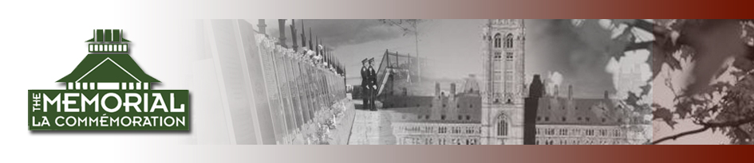

Canadian Memorial Celebration
September 24-September 26, 2004

Please fill out this page and return it with your payment.

The Canadian Memorial Celebration in the beautiful city of Ottawa, Canada, will take place on September 26-September 29, 2014.

Travel will be by Van and we will be staying at the Embassy Suites on the corner of Cooper and Cartier Street. It is walking distance to the Cancel, many restaurants, the Canadian Police Hall or Russell’s Lounge, Parliament, and to the Market.

LIMITED SEATS ARE AVAILABLE WE CAN ONLY TAKE 14 PEOPLE
SIGN UP EARLY…WE WILL HOLD YOUR SEAT UNTIL YOU MAKE PAYMENT. Any unpaid reservations will be available after August 22, to anyone on the waiting list.

A schedule of the events is also attached.

The cost will include the Van, tolls, to and from Ottawa, 3 nights at the hotel:

Non – Member Pricing*
$285.00 per person double occupancy

Members Pricing*
$235.00 per person double occupancy

*you must have a passport or the passport card to attend.

Full payment to reserve your seat is due August 22, 2014. If the event is already filled prior receipt of your payment, it will be returned to you.

Please join us this September as we honor the Canadian Officers!! This is a memorable weekend of fellowship and camaraderie with other officers. If you have any questions please call me at 216-410-7583 or e-mail at bonnetta@adalet.com.

Name:_______________________________________________________________________

Adress:_______________________________________________________________________

City/State/Zip:__________________________________________________________________

Telephone
number:______________________________________________________________________

e-mail:________________________________________________________________________

Enclosed is my non-refundable payment of $__________for___________person(s).

I wish to room
with:_____________________________________________________________________
Make checks payable to GCPOMS and mail to 1300 Ontario Street, Cleveland, OH 44113

